**Please follow the below steps**:-

* Open outlook and click on file

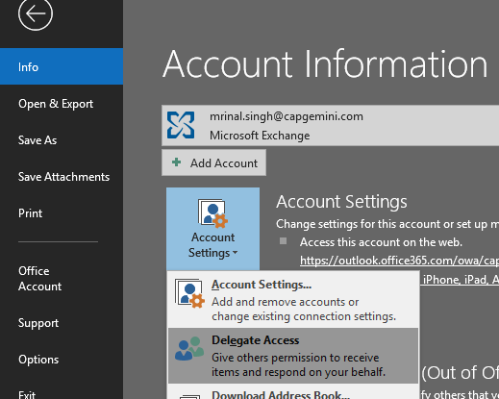

* Click on ‘Add’ on the next window: 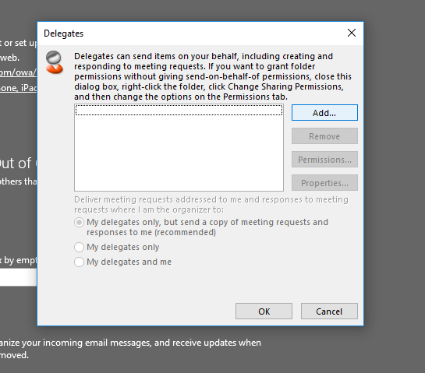
* Select the members to be selected as delegate:

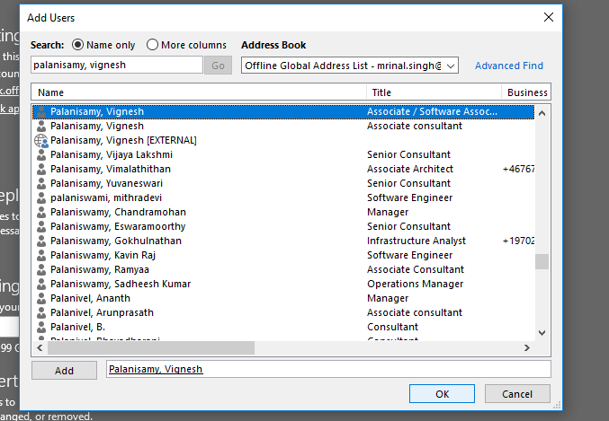

* Now, select the level of access as needed on the next window:

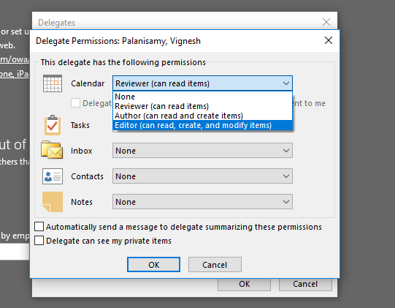

* Click ‘OK’ and ‘OK’